**Texture Transforms plus Interactivity**

Tests that demonstrate X3D’s <TextureTransform> node, which sets: translation, rotation, scale and center. Demo’s include interactivity and animation via JavaScript.

**texturetransform.x3d**

Five texture transforms. The upper left has a translation of (.3, .2); upper right has a scale of (2, 3). Middle plane has a rotation of .785 radians (45 degrees), center (-.5, -.5) and scale (2, 2).

The lower left has a rotation of .785 radians, center (-.5, -.5); the lower right also has a rotation of .785 radians but center of (0, 0), meaning the rotation of the texture map is around the bottom left corner.

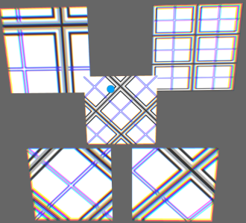

**texturetransform_JS_translation.x3d**

Upper left plane has a translation of (.3, .6); the upper right has a translation of (.6, .1). Rolling over the yellow Cone changes it to green the translation of the foreground plane to (.3, .6), matching the upper left plane. Rolling off the Cone changes its color to purple and the foreground plane translation is now (.6, .1), matching the upper right plane.

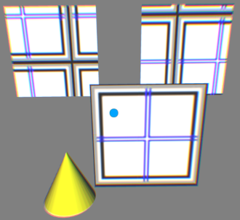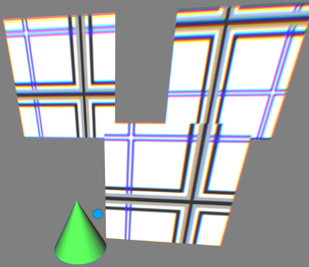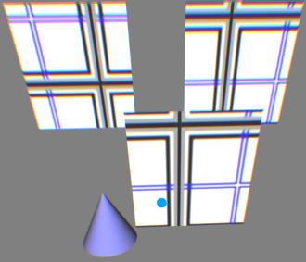

**texturetransform_JS_translation_getSet.x3d**

Rolling over the Cone will increment the Texture Coordinate translation X-value by .1.

Rolling off the Cone changes it from green to purple and increments the Texture Coordinate translation Y-value by .2. The other two upper planes don’t have any significance in this demo.

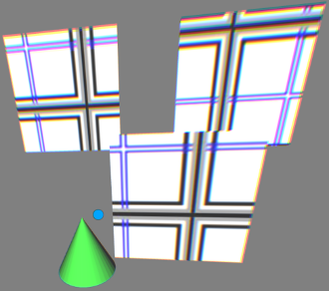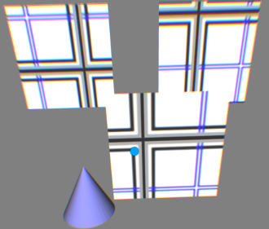

**texturetransform_JS_translation_anim.x3d**

The Texture Map on the foreground plane increments (.001, .002) per frame, animating of the texture map. The other two upper planes don’t do anything in this demo; there is not interactivity in this demo.

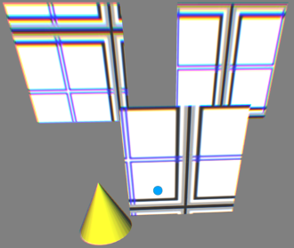

**texturetransform_JS_rotation.x3d**

Upon initialization, there is no rotation of the texture map on the foreground plane. Rolling over the green Cone changes the rotation of the texture map to .2 radians, matching the upper left plane. Rolling off the Cone changes it to purple and rotates the texture map to .5 radians, matching the upper right plane. The orange Cone does nothing.

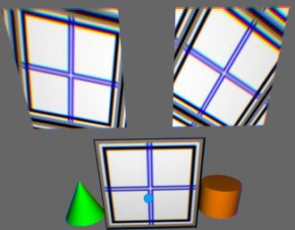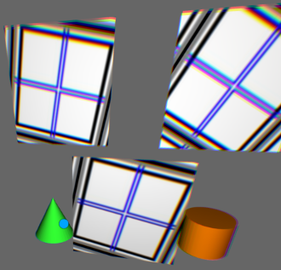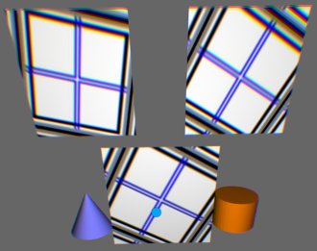

**texturetransform_JS_rotation_getSet.x3d**

The upper left plane has a texture translation of .2 radians; the upper right plane has a texture translation of .5 radians. Rolling over the green Cone will increment the foreground plane’s texture map by .4 radians. Rolling off the Cone changes it to purple an decrements the texture map’s rotation .2 radians. All the planes have a Textrue translation center set to (-.5, -.5) so it rotates around the center.

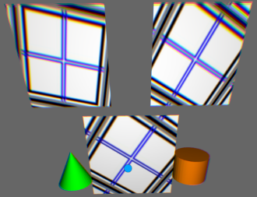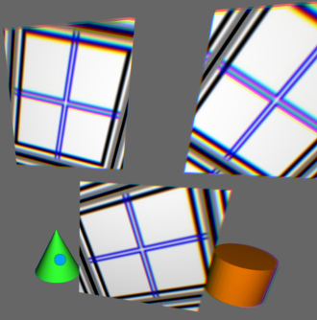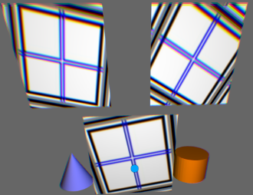

**texturetransform_JS_rotation_anim.x3d**

This demo increments the rotation of the texture map by .0015 radians per frame. The yellow Cone has no impact. The Textrue translation center isset to (-.5, -.5) so it rotates around the center.

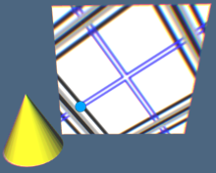

**texturetransform_JS_scale.x3d**

This demo changes the scale of the texture map. The upper left texture map scales (2, 3). The upper right scale the texture map to (3, .5). The foreground texture map begins with the default scale (1, 1). Rollinf over the yellow Cone changes it to green and scales the texture map to (2, 3) matching the upper left plane. Rolling off the Cone changes it to purple and the texture map scale to (3, .5), matching the upper right texture map.

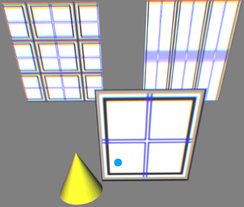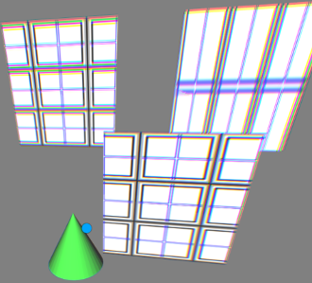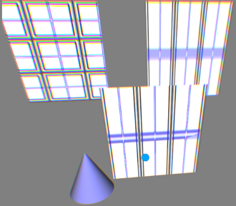

**texturetransform_JS_scale_getSet.x3d**

The foreground plane has a texture transform scale set to default of (1,1). Rolling over the yellow Cone changes in to green and increments the foreground plane’s texture map scale X value by .1. Rolling off the Cone changes it to purple and increments the texture map’s scale Y value by .2.

The upper left plane has a texture transform scale of (1.5, 2); the upper right plane has a texture transform scale (2, 3). Neither of the upper planes is impacted by the interactivity.

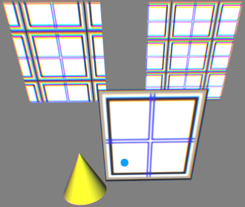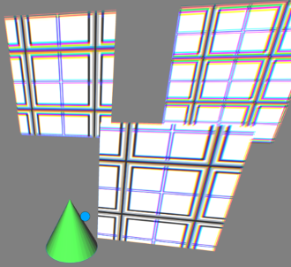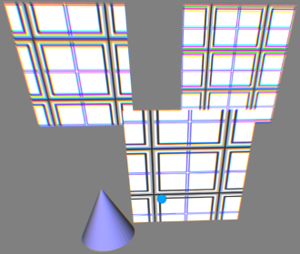

**texturetransform_JS_scale_anim.x3d**

The upper left plane has a texture transform scale of (4, 5); the upper right plane has a texture transform scale (.2, .25). The foreground plane has a texture transform scale set to default of (1,1). The yellow Cone has no role in this animation.

The foreground plane animates its texture map’s scale from (4, 5), matching the upper left plane, to (.2, .25), matching the upper right plane. This is a continuous animation, but no interactivity in this demo.

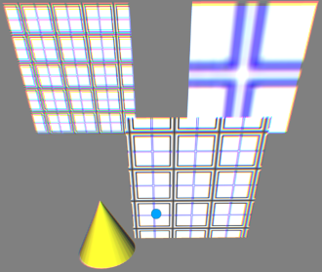

**texturetransform_JS_center.x3d**

All three planes have texture map rotations of .785 radians (45 degrees). The upper left plane has a texture transform center of (.6, .3); the upper right plane has a texture transform center of (.2, .7). The foreground plane has a texture transform center set to (-.5, -.5).

Rolling over the yellow Cone changes it to green and changes the texture transform center to (.6, .3), matching the upper left plane. Rolling off the Cone changes it to purple and changes the texture transform center to (.2, .7) matching the upper right plane.

